**IMPLEMENTATION/INTERFACING OF SEVEN SEGMENT DISPLAY ON FPGA (NEXYS 4) BOARD.**

**SCHEMATIC**

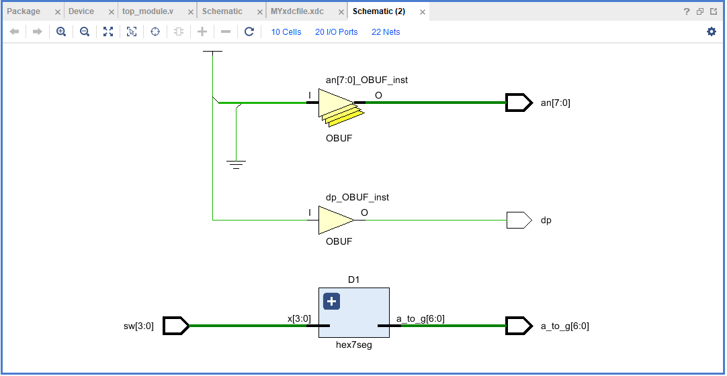

**Verilog/source code**

module top_module(

input wire [3:0] sw,

output wire [6:0] a_to_g,

output wire [7:0] an,

output wire dp

);

assign an = 8'b11111110;

assign dp = 1;

hex7seg D1(.x(sw), .a_to_g(a_to_g));

endmodule

//////////////////////////////////////////////////////////////////////////////////

//////////////////////////////////////////////////////////////////////////////////

module hex7seg(

input wire [3:0]x,

output reg [6:0]a_to_g

);

always@(*)

begin

case(x)

0: a_to_g = 7'b0000001;

1: a_to_g = 7'b1001111;

2: a_to_g = 7'b0010010;

3: a_to_g = 7'b0000110;

4: a_to_g = 7'b1001100;

5: a_to_g = 7'b0100100;

6: a_to_g = 7'b0100000;

7: a_to_g = 7'b0001111;

8: a_to_g = 7'b0000000;

9: a_to_g = 7'b0000100;

'hA: a_to_g= 7'b0001000;

'hB: a_to_g= 7'b1100000;

'hC: a_to_g= 7'b0110001;

'hD: a_to_g= 7'b1000010;

'hE: a_to_g= 7'b0110000;

'hF: a_to_g= 7'b0111000;

default: a_to_g = 7'b0000001;

endcase

end

endmodule

**MYxdcfile.xdc**

set_property IOSTANDARD LVCMOS33 [get_ports {a_to_g[6]}]

set_property IOSTANDARD LVCMOS33 [get_ports {a_to_g[5]}]

set_property IOSTANDARD LVCMOS33 [get_ports {a_to_g[4]}]

set_property IOSTANDARD LVCMOS33 [get_ports {a_to_g[3]}]

set_property IOSTANDARD LVCMOS33 [get_ports {a_to_g[2]}]

set_property IOSTANDARD LVCMOS33 [get_ports {a_to_g[1]}]

set_property IOSTANDARD LVCMOS33 [get_ports {a_to_g[0]}]

set_property IOSTANDARD LVCMOS33 [get_ports {an[7]}]

set_property IOSTANDARD LVCMOS33 [get_ports {an[6]}]

set_property IOSTANDARD LVCMOS33 [get_ports {an[5]}]

set_property IOSTANDARD LVCMOS33 [get_ports {an[4]}]

set_property IOSTANDARD LVCMOS33 [get_ports {an[3]}]

set_property IOSTANDARD LVCMOS33 [get_ports {an[2]}]

set_property IOSTANDARD LVCMOS33 [get_ports {an[1]}]

set_property IOSTANDARD LVCMOS33 [get_ports {an[0]}]

set_property IOSTANDARD LVCMOS33 [get_ports {sw[3]}]

set_property IOSTANDARD LVCMOS33 [get_ports {sw[2]}]

set_property IOSTANDARD LVCMOS33 [get_ports {sw[1]}]

set_property IOSTANDARD LVCMOS33 [get_ports {sw[0]}]

set_property IOSTANDARD LVCMOS33 [get_ports dp]

set_property PACKAGE_PIN U9 [get_ports {sw[0]}]

set_property PACKAGE_PIN R7 [get_ports {sw[2]}]

set_property PACKAGE_PIN R6 [get_ports {sw[3]}]

set_property PACKAGE_PIN U8 [get_ports {sw[1]}]

set_property PACKAGE_PIN M4 [get_ports dp]

set_property PACKAGE_PIN L3 [get_ports {a_to_g[6]}]

set_property PACKAGE_PIN N1 [get_ports {a_to_g[5]}]

set_property PACKAGE_PIN L5 [get_ports {a_to_g[4]}]

set_property PACKAGE_PIN L4 [get_ports {a_to_g[3]}]

set_property PACKAGE_PIN K3 [get_ports {a_to_g[2]}]

set_property PACKAGE_PIN M2 [get_ports {a_to_g[1]}]

set_property PACKAGE_PIN L6 [get_ports {a_to_g[0]}]

set_property PACKAGE_PIN N6 [get_ports {an[0]}]

set_property PACKAGE_PIN M6 [get_ports {an[1]}]

set_property PACKAGE_PIN M3 [get_ports {an[2]}]

set_property PACKAGE_PIN N5 [get_ports {an[3]}]

set_property PACKAGE_PIN N2 [get_ports {an[4]}]

set_property PACKAGE_PIN N4 [get_ports {an[5]}]

set_property PACKAGE_PIN L1 [get_ports {an[6]}]

set_property PACKAGE_PIN M1 [get_ports {an[7]}]

**DEVICE**

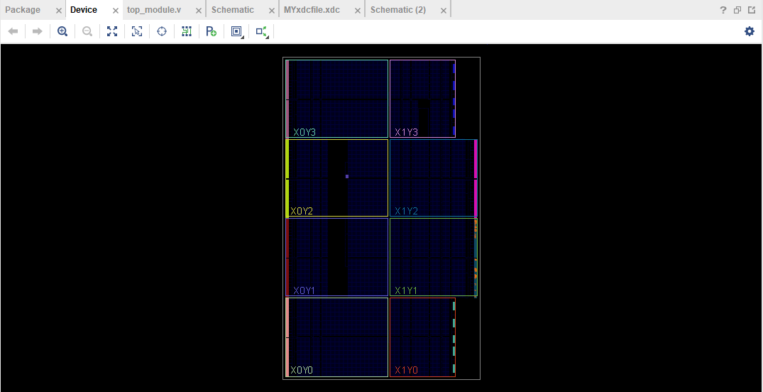

**PACKAGE**

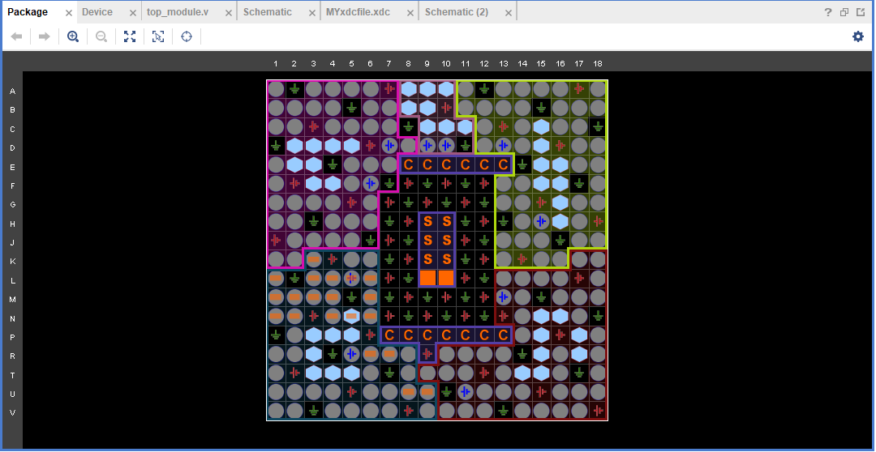

**FPGA BOARD (NEXYS 4)**



**General Purpose I/O devices on the Nexys 4**

